Geodesic Baubles
1 | Cut out 20 circles of coloured paper or card  Approx 1.5” in diameter. To ensure that no colours ever appear next to each other you need to use three colours (2x5 circles and 1x6 circles) | 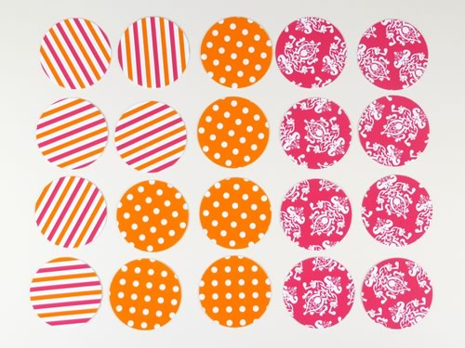
2 | Make a triangle template  Cut another circle (plain paper is fine) and fold it into quarters, open it out and fold three sides into the middle as shown here | 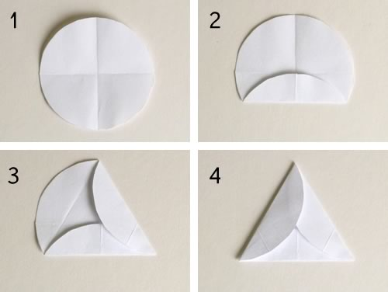
3 | Fold all circles into triangles  Place the triangle template onto a circle and fold the sides up into a triangle. Repeat for all the circles | 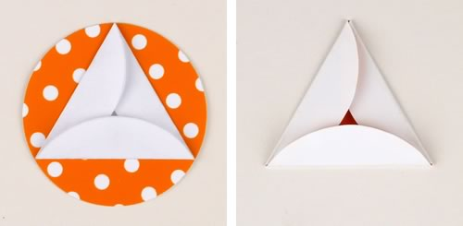  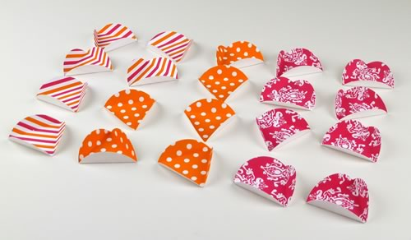
4 | Glue 5 triangles together | 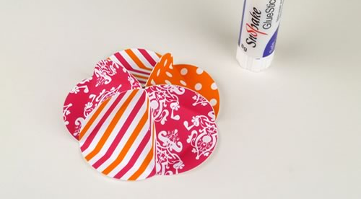
5 | Add a ribbon loop | 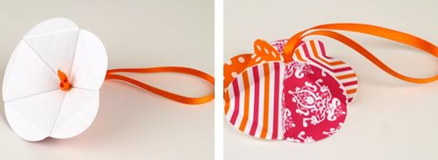
6 | Glue 5 more triangles together so you now have the top and bottom of the bauble. | 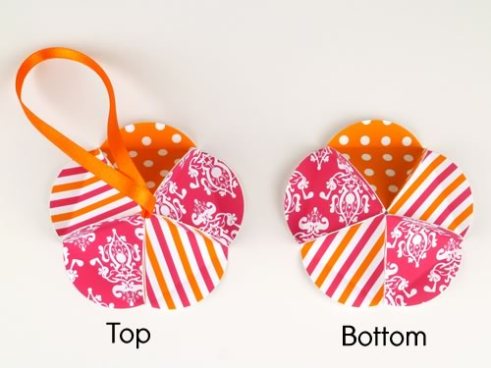
7 | Glue 10 triangles together to make a strip
8 | Glue top, middle & bottom together as shown | 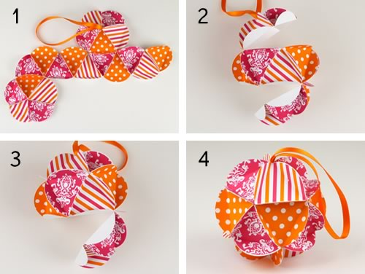
9 | FINISHED!
